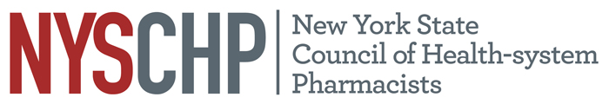
230 Washington Ave Extension, Albany NY 12203 - 518-456-8819

TO: Delegates, Alternate Delegates and Past Presidents
2017 House of Delegates

FROM: Marcia Gutfeld
Chair, House of Delegates

SUBJECT: Notice of Open Hearing and Open Hearing Conference Call

An open hearing conference call will be held on April 7, 2017 at 12 noon. To participate in this conference call, please call (712) 770-4700 and use Access Code: 533314.
The live open hearing will be held on Thursday, April 27, 2017 from 1:00 PM to 1:45 PM at the Sagamore, Bolton Landing, New York.
The purpose of the conference call and the meeting is to provide all Council members with the opportunity to discuss any topic related to health-system pharmacies in New York State, the operation and activities of the NYSCHP, and any appropriate matters for consideration by the NYSCHP House of Delegates and NYSCHP Board of Directors.

All delegates are requested to canvass the membership of your chapter and bring forward matters of concern. In addition, members should be encouraged to attend and participate in this session.

If you have any questions, please feel free to contact the Council Office at (518) 456-8819.

Thank you.
Agenda
- Greetings and HOD Overview Marcia Gutfeld, Chair
- Parliamentary Procedure Overview Tom Lombardi, Parliamentarian
- Legislative Update Monica Mehta, Vice President Public Policy
- Resolution Update Liz Shlom, Chair Committee on Resolutions
- Membership Update Bill Prescott, Director of Chapter Services
- Open Forum Delegates and the BOD

